**Routing To The Html Page**

Date

Team ID

Project Name

17November 2022

PNT2022TMID34036

AI-powered Nutrition Analyzer for Fitness

Enthusiasts

Here, the declared constructor is used to route to the HTML page created earlier.

In the above example, the ‘/’ URL is bound with the home.html function. Hence, when the home page of the webserver is opened in the browser, the HTML page is rendered. Whenever you enter the values from the HTML page the values can be retrieved using the POST Method.

Here, “home.html” is rendered when the home button is clicked on the UI

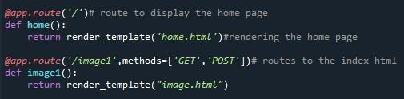

When “image is uploaded “on the UI, the launch function is executed



It will take the image request and we will be storing that image in our local system then we will convert the image into our required size and finally, we will be predicting the results with the help of our model which we trained and depending upon the class identified we will showcase the class name and its properties by rendering the respective html pages.

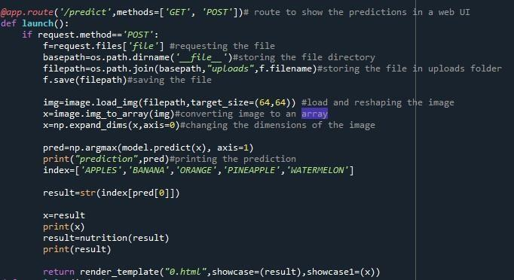

API Integration:

Here we will be using Rapid API

Using RapidAPI, developers can search and test the APIs, subscribe, and connect to the APIs

— all with a single account, single API key and single SDK. Engineering teams also use RapidAPI to share internal APIs and microservice documentation.

[Reference link](https://rapidapi.com/marketplace)

API used: [Link](https://rapidapi.com/calorieninjas/api/calorieninjas)

The link above will allow us to test the food item and will result the nutrition content present in the food item.

NOTE: When we keep hitting the API the limit of it might expire. So making a smart use of it will be an efficient way.

How to access and use the API will be shown in this [video](https://github.com/Guided-Projects/Nutrition_Image_Analysis_Using_CNN_Rapid-API/tree/main/Rapid%20API%20Video)

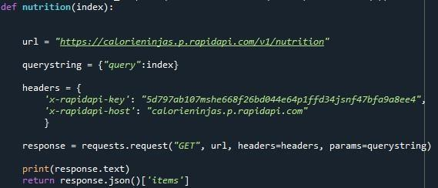

Finally, Run the application

This is used to run the application in a localhost. The local host runs on port number 5000.(We can give different port numbers)

